Results:

The first Curatorial Laboratory in Benin:
The ten art history students of UAC had for the first time the opportunity to work with contemporary artists. All works were site specific and the media ranged from performance, video to painting and drawing. Due to the English classes Kulturforum organized for them, they managed to communicate with guests that cannot speak French. They had the opportunity to identify and contract new venues on the threshold between public and private, shop windows for example. They wrote short essays for the Journal of the Biennale Regard Benin, and gained insight how to edit publications that accompany an exhibition. They organized several press conferences. The experience of programming and realizing Take, Take, Take and ..? changed the vision of their post graduate careers, and made them aware, that it is also up to them to create future opportunities in a country that lacks structures for art.

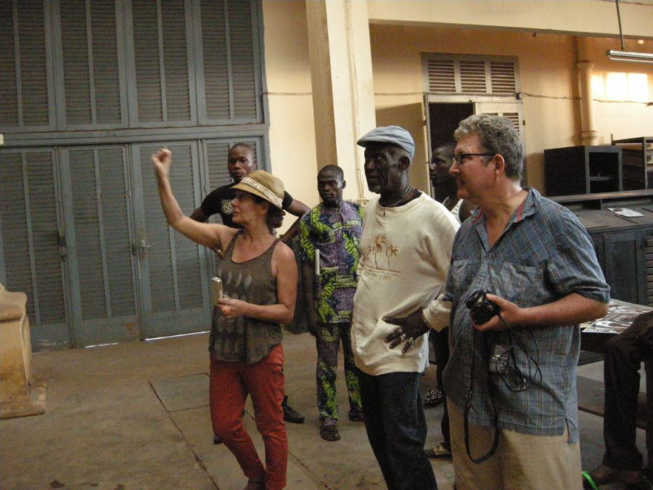
Daphné Bitchatch, Beaugard Koukpaki, Sidoine Avadji, Georges Adéagbo, Stephan Köhler installing Daphné’s work in the National Print – Shop Nov. 2012

The Public and the Press
We had neither time nor technical means to count the public attending. We assume that about 5000 persons have seen the shows of Take,Take,Take and..? that spread out like a capillary system in Cotonou and Porto Novo. From the discussions triggered, we The exhibition sensitized the viewers and invited them to reflect about their own attitudes, habits and neglected responsibilities towards their environment and themselves, as a part of nature. About 50 newspaper articles appeared in Benin and abroad between October and December 2012. For a selection see “press”.

The Historic Spaces of the National Print Shop in Porto Novo
The space was abandoned in 1992, when the Official Journal of Benin began to be printed offset. The space was used for the first time for a contemporary art exhibition. The event was a proof, that the space is perfect for such events: The artists were inspired to dialogue with the history of the space, the public could both experience innovative contemporary positions and have insight into

Projects that grew out of Take, Take, Take and..?

While installing together for about 10 days, the artists and young curators from the art history departments exchanged their visions, became friends and launched new projects.

Four artists from Hamburg University of Art HFBK Eylien König, Martina Mahlknecht, Doris Schmidt, Martin Prinoth founded the group “Yovo! Yovo!” while working in Porto Novo on their piece “Enframing Home”. Yuko Hasegawa, artistic director of this year’s Sharjah Biennial invited the group to participate with a new site specific version of the piece.

Zon Sakai, Yuki Asai, Daphné Bitchatch and Tara Mahapatra, who met installing at Take, Take, Take and..? launched a joined exhibition project in Japan for autumn 2013.

New Impulses for artists in Benin:

As in the previous exhibition “Running does not help” we gave young Benin-based artists the opportunity to get to know artistic strategies, which they otherwise would not see in their country. Our exhibitions are in general intended to catalyze discussions, an open Forum, which could one day crystallize as a an innovative art-school in collaboration our partners in Benin. (as of now, there is no art school in Benin) The exhibition theme and process gave abundant possibilities to reflect upon the identity and role of the artist in relation to what nature has to offer as source of energies, creative or destructive ones. During the exhibition, we discussed with artists and visitors the changes and challenges to the artists’ role in a society dominated by speculations and capital rationalism. The animation film workshop on Land Grabbing by Alice Creischer and Andreas Siekmann was a perfect example how artists can get creatively involved in shaping their societies.

